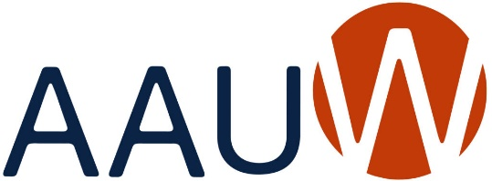
Our Mission: Advancing equity for women and girls through advocacy,
education, philanthropy and research.

AAUW Owatonna Branch MEMBERSHIP APPLICATION 2023-2024

PERSONAL INFORMATION Application Date_______________________

Name_________________________________________________________________________

Street ________________________________________________________________________

City______________________________________ State___________ Zip Code_____________

Phone (cell)________________________________ (home)_____________________________

Email (please print) _____________________________________________________________

EDUCATION
College/University | City/State | Degree/Graduation Year

MEMBERSHIP

DUES: 2023-2024
AAUW National $72.00
AAUW MN $ 9.00
Owatonna Branch $ 10.00
$91.00

Please make your check payable to AAUW Owatonna. Mail your check and completed application to: Linda Boorman, 1250 Edgewood Pl, Owatonna, MN 55060

