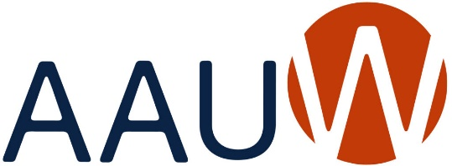
Our Mission: Advancing equity for women and girls through
advocacy, education and research.
AAUW Owatonna Branch NEW MEMBERSHIP APPLICATION 2024-2025

PERSONAL INFORMATION Application Date_______________________________

Name_________________________________________________________________________

Street ________________________________________________________________________

City______________________________________ State___________ Zip Code_____________

Phone (cell)______________________________________(Other)________________________

Email (please print) _____________________________________________________________

EDUCATION
List College/University, City and State | Please list Type of Degree (e.g., A.A., B.S., M.A. etc.),  Graduation Year (include month and day if possible) and your major and specific areas of study related to the degree.
 | Highest Degree:
 | Degree:

Dues 2024-2025
AAUW National $36.00 (Normally $72 but Shape the Future discount of 50% your first year)
AAUW MN $ 9.00
Owatonna Branch $ 10.00
$55.00
Please make your check payable to AAUW Owatonna. Mail your check and completed application to: Linda Boorman, 1250 Edgewood Pl, Owatonna, MN 55060

