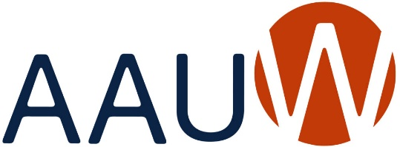
Our Mission: Advancing equity for women and girls through
advocacy, education and research.
AAUW Owatonna Branch NEW MEMBERSHIP APPLICATION 2025-2026

PERSONAL INFORMATION Application Date_______________________________

Name_________________________________________________________________________

Street ________________________________________________________________________

City______________________________________ State___________ Zip Code_____________

Phone (cell)______________________________________(Other)________________________

Email (please print) _____________________________________________________________

EDUCATION
List College/University, City and State | Please list Type of Degree (e.g., A.A., B.S., M.A. etc.),  Graduation Year (include month and day if possible) and your major and specific areas of study related to the degree.
 | Highest Degree:
 | Degree:

Dues 2025-2026
AAUW National $37.00 (Normally $74 but Shape the Future discount of 50% your first year)
AAUW MN $ 9.00
Owatonna Branch $ 10.00
$56.00 (Normally $93)
Please make your check payable to AAUW Owatonna. Mail your check and completed application to: Kay Oberle, 50 18th Place NE, Owatonna, MN 55060

